
Dear Parents
NOTICE OF GENERAL MEETING WITH SCHOOL GOVERNING BODY OF PINEDENE PRIMARY SCHOOL
Notice is hereby given of the second opportunity for a General Meeting with the School Governing Body.
All parents are cordially invited to attend this meeting.
Please see the prescribed agenda below.
Date: 24 June 2026 | Time: 18:00 | Venue: Pinedene Primary School
Agenda:
- Opening, Welcome, Attendance and Apologies
- Confirmation of the agenda
- Confirmation of the quorum
- Annual Financial Statements 2025
- Announcements
- Closure
GAUTENG DEPARTMENT OF EDUCATION
PINEDENE SCHOOL
 1 7 -06- 2026 
TEL: (016) 023 0295 e-maiE: info@pinedene.co.za
P.o BOX 626. VANDERBIJLPARK. 1900
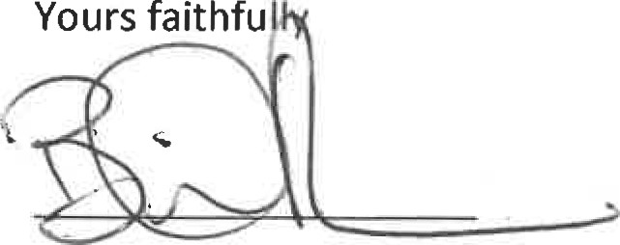
B.D. DU PONT (PRINCIPAL)

